Activity 1: UML Final Project – Title & Design Proposal

PROJECT TITLE: Hulyanas Hill Information and Ordering System
PROBLEM STATEMENT: Many food ordering processes in small- to medium-sized establishments like Hulyanas Hill are still handled manually or through unorganized systems, leading to inefficiency, delays, and potential errors in order processing. Customers often experience difficulty in browsing available menu items, tracking their orders, and receiving accurate transaction details. On the other hand, administrators struggle to manage menu updates, monitor orders, and keep customer records organized. These challenges result in poor customer experience and inefficient business operations.
PROJECT OBJECTIVES
The main objective of the Hulyanas Hill Information and Ordering System is to develop a web-based platform that improves the efficiency and accuracy of the ordering process for both customers and administrators.
Specifically, the system aims to:
- Provide customers with an easy-to-use online ordering platform.
- Allow users to register, log in, and manage their accounts securely.
- Enable customers to browse menu items, manage carts, and complete transactions smoothly.
- Provide order tracking, order history, and invoice generation features.
- Help administrators manage menu items (add, update, delete).
- Allow administrators to monitor orders and user information efficiently.
- Improve overall service delivery and operational efficiency.
TARGET USERS: The proposed system is primarily intended for customers who want to visit and order from Hulyanas Hill. This includes individuals, families, students, and travelers who wish to browse available menu items, place orders, and track their purchases conveniently online. It also supports administrators of Hulyanas Hill who manage the system by updating menu items, monitoring orders, and handling user information. Additionally, potential visitors who want to view available food options and related details before ordering may also benefit from the system.
SYSTEM SCOPE: The system covers the development of a web-based ordering and information platform for Hulyanas Hill that provides organized details about menu items, user accounts, cart management, order processing, and invoice generation. It includes features such as user registration and login, browsing of menu items, adding and removing items from the cart, checkout and order placement, order tracking, and admin management of products and orders. The system focuses on improving the ordering and management process and does not include advanced features such as full delivery tracking or integrated online payment processing.

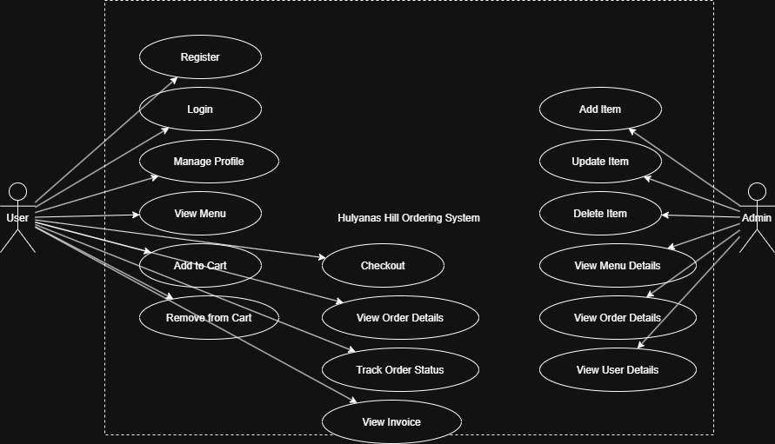
UML DIAGRAM (USE CASE DIAGRAM)

